Chapter 17, Solution 78.

(a) p = 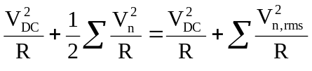

= 0 + (40²/5) + (20²/5) + (10²/5) = 420 W

(b) 5% increase = (5/100)420 = 21

p_{DC} = 21 W = 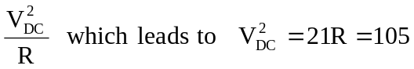

V_{DC} = 10.25 V

